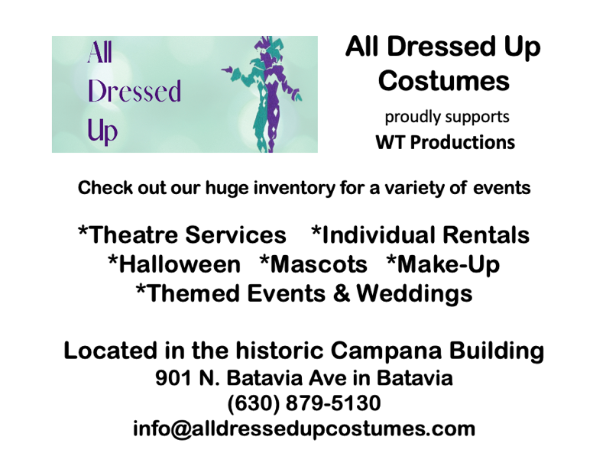
Special Thanks
STC Theater Tara Frost & Andy Peckys Julane Sullivan All Dressed Up Costumes David Dowell Ben Vargas Steve Delaney Kathy Cichon Renee Tomell Chuck & Denise Bennorth Dennis Brown & Dawn Harkins The Seasonal Bags Cast You, the Audience
Visit our website to find out about future WT Productions
wtproductions2.weebly.com

Written, Produced, and Directed by
Debbi Dennison & Carl Zeitler

December 2-4 & 9-11, 2022
STC Theater
In Cahoots
Written and Directed by Carl Zeitler
Featuring Debbi Dennison (Sonja), Katelyn Lane (Marilyn), Stephen Pickering (Jack), and Erick Sosa (Marty)

The Last Noel
Written and Directed by Debbi Dennison
Featuring Mark Brewer (Walker), Gail Cannata (Eve), Nikolai Sorokin (Jogger), and Carl Zeitler (Nick)

Misfit Camping
Written and Directed by Debbi Dennison & Carl Zeitler
Featuring Mark Brewer (Don), Debbi Dennison (Hannah), Stephanie Turner O’Kelley (Vix), Kate Roberts (Rudy), and Nikolai Sorokin (Dash)

15-minute intermission

Rise and Shine
Written and Directed by Carl Zeitler
Featuring Gail Cannata (Betty), Stephanie Turner O’Kelley (Shelley), and Nikolai Sorokin (Ted)

The Masked Bagger
Written and Directed by Debbi Dennison
Featuring Mark Brewer (Stan), Katelyn Lane (Bonnie), Stephen Pickering (Christmas Drunk), Kate Roberts (Becky), Nikolai Sorokin (Stage Manager), and Carl Zeitler (Holiday Thief)

Mixed Bag
Written and Directed by Debbi Dennison & Carl Zeitler
Featuring THE ENTIRE CAST

Carl Zeitler – Carl has been active in a variety of roles at numerous theatres around the Chicagoland area since 2003. He directed Becky’s New Car for Village Theatre Guild, wrote and directed Relationships in Progress for VTG and Gallery Theater, and wrote and directed Reflections and Perspectives for Elgin Theatre Company. Some of his favorite roles over the years include The House of Yes (Anthony), Closer (Dan), Over the River and Through the Woods (Nick), Of Mice and Men (Lennie), Boy Gets Girl (Tony), The Odd Couple (Felix), and The Shadow Box (Joe). Carl is beyond grateful that the Seasonal series has reached its fifth year. He thanks STC Theater and Tara Frost for their hard work in keeping theater alive here. Julane Sullivan was wonderfully generous to allow rehearsals at All Dressed Up. This terrifically talented cast has been great with which to work. Carl is honored to partner with Debbi on WT Productions’ projects. She brings originality, passion, energy, determination, and vision to each one. Enjoy the show!

Troy (Himself) – Troy thinks it doesn’t suck to be performing at the STC Theater. Previously he was seen in SEASONAL TAGS, SEASONAL WRAPS, SEASONAL BOWS and SEASONAL TIES. When not on stage, Troy is a party DJ along with his old pal “DJ Meowy Mouse.” Troy thanks Debbi for keeping him around since she was a little girl. He thanks Milo for not chewing on him the last two years, but he will have a very watchful eye on kitten Simon! Troy dedicates this performance to Dennis Brown and Dawn Harkins for recognizing that puppets have talent too.

Roy (Himself) – Roy is so happy, although it’s often hard to tell from his demeanor, to be back onstage. When not taking judo lessons, playing the triangle in his jazz band Maroon Waterfall, or volunteering at various petting zoos, Roy spends his time getting his new podcast The Joy of Roy off the ground. His first guest will be Dennis Brown. Be sure to catch it when it launches. Roy wishes you and your family a Happy Solstice!

the upcoming feature film The Grey Girl. Stephen would like to thank Debbi and Carl; his castmates; Amy, Kyleen, Will, and Simon; Madeline, Julie, Jennifer, and the Effervescence of Elizabeths.

Kate Roberts – This is Kate's second Seasonal Palooza Deluxe. Last year she appeared as Ginger in Seasonal Tags and had a great time doing it, so she forced Debbi and Carl to put her in the show again or else. She'd like to give a shoutout to her mom, dad, brother Matthew, and friends Kassidy, Rick, Meghan, Frances, Katie, and Joe for looking in her direction. And also for being super supportive. Kate is terrified of Pelicans. Enjoy the show!

Nikolai Sorokin – Nikolai is thrilled to be performing his first show with WT Productions! Some of his favorite roles have been Charlie Brown (You're a Good Man, Charlie Brown), Seymour (Little Shop of Horrors), and Cinderella's Prince/The Wolf (Into the Woods). Besides acting, you can often see him sing on Instagram @nikanasor or on his YouTube channel. He is so excited to be a part of this completely unique show! Ready, Rudy!

Erick Sosa – Erick returns to the “Seasonal Show” family after debuting last year in Seasonal Tags. He’s appeared in local theater productions since the turn of the century. He has recently appeared in GreenMan Theatre’s Ninja Pirate Princess and Ghost Pirate Prince as well as completing his first turn as a Director for Westchester Civic Theatre’s 8x10 Play Festival. In addition to acting, Erick is a lifelong basketball and wrestling fan who also enjoys creative writing. He is currently in the final editing stages of his first original play.

Notes from the Directors

To those that have seen a SEASONAL show before, your support is much appreciated. To those that make our SEASONAL show a yearly tradition, wow! That truly is a dream come true. And if this is your first SEASONAL experience, a hearty welcome! Since you are new, I’d like to offer one suggestion…be prepared to not be prepared. I think you’ll find this is not your traditional holiday show. We like to think outside the box. We like to examine the honesty of the season. And we like to explore all kinds of situations, characters, and emotions. You could say our show is a mixed "seasonal bag".

May the holidays be everything you imagine them to be and more.

– Debbi Dennison

I don’t know when something becomes a tradition, but these shows are definitely that for me. It is enriching to be able to bring different stories and moods to life. I look forward to working with actors in their first Seasonal show while welcoming back veteran (seasoned Seasonals?) actors to the new production. The people we meet in our lives help shape our expression. I treasure the experiences that inspire what comes out expressed on the page and those who breathe a new life into them. I hope you give and receive meaningful gifts this holiday season, be they in a bag or not.
– Carl Zeitler

Show Biographies
Mark Brewer – Mark is thrilled to be back for his second Seasonal outing after playing Doug the Hotdog in last year's Seasonal Tags. He has had the fortune to appear with several theater companies in the Chicagoland area. Most recently he was Juror 10 in 12 Angry Men and Otis the Bellhop in Suite Surrender for The Parker Players. With Oakton Community College, he's appeared as Otto Frank in The Diary of Anne Frank, Brian in The Shadow Box, and Charlie in The Foreigner. Other favorite roles include Renfield in Dracula and Dr. Lyman in Bus Stop for James Downing Theatre, Jonathan Brewster in Arsenic and Old Lace and Leo/Maxine in Leading Ladies for Theater D, and Jack/Stephanie in Leading Ladies and "All the Men" in A Piece of My Heart for Elgin Community Theater.

Gail Cannata – Gail is happy to be back on the “Seasonal” team. Although most of Gail’s theater credits in the past 10 years are for directing, she does occasionally enjoy being on the stage as well. Some notable directing credits include: The Cemetery Club, Tuesdays with Morrie, Making God Laugh, The Kitchen Witches, Grace & Glorie, Suite Surrender, Rose Colored Glass, and many more. Cheers to a happy holiday season and thank you for supporting Debbi, Carl, WT Productions & STC Theater.

Debbi Dennison – Debbi is thrilled to continue the SEASONAL tradition! Favorite roles include Belinda/Flavia (NOISES OFF), Sis (LEAVING IOWA) and Faye (CHAPTER TWO) and the many characters in murder mystery shows co-written with Carl. Debbi trained at the Second City Training Center. Her improv group LOBSTER STOLE performs at Laugh Out Loud Theater and at the Bit Theater. Offstage, Debbi works as a Multimedia Producer and a freelance Camera Operator (Schaumburg Boomers, Chicago Steel, etc.). She thanks Tara Frost, the cast, the audience, Brian, Julane, and last but not least, Carl for being “in cahoots” with her for this “WT/SEASONAL” journey. Debbi dedicates this show in memory of her “clown” Otis.

Katelyn Lane – Katelyn is thrilled to be a part of Seasonal Bags! It is her debut with WT Productions. She holds her B.F.A. in Acting from Northern Illinois University. Katelyn is a transplant who has been in the Chicago acting community since 2016. She has worked with On the Spot Theatre Company as Martha in What About Martha as well as Rally Theatre Company and Trap Door. She appeared in a Feldco commercial in April of this year and also just wrapped a commercial for Cars.com. She also worked on two short films one of them was SAG. When not doing acting, she loves spending time with her kitty cat Luna and friends.

Stephanie Turner O’Kelley – Stephanie is thrilled to be joining her first STC show! She holds a BA in Musical Theatre from Elmhurst University. Previous credits include The Merry Wives of Windsor (Pistol/Rugby/Jean) at Shakespeare at the Centre, Cabaret (Texas), Violet (Young Violet), and The Pajama Game (Pat) at Elmhurst University, as well as The Addams Family (Alice Beinecke), Much Ado About Nothing (Hero), and Girls Like That (Ensemble) at College of DuPage. Much thanks to family, friends, and her husband, Christian, for their never-ending love and support.

Stephen Pickering – Stephen Pickering is thrilled to make his third “Seasonal” appearance, previously performing in Seasonal Tags and Seasonal Ties. Favorite area credits include: Theatre 121 - Noises Off (Selsdon, Lou Award); Parker Players - The Spider’s Web (Rowland), 12 Angry Men (Juror 4); Elgin Theatre Company – Pygmalion (Higgins), The Importance of Being Earnest (Chasuble, Broadway World nomination); Fremont Street Theater Company - Anything Goes (Evelyn), Crazy for You (Zangler), How to Succeed. (Biggley), Beauty and the Beast (Cogsworth); Film credits include

